**A**

**Project Report on**

ONLINE CAR FAIR

As a partial fulfillment of B.C.A. SEM VI

Batch Year (2019-2020)

**Under taken at**

Matrushri L. J. Gandhi(Bakorwala) BCA College,

Modasa

**Submitted By**

Name Roll No

Parmar Vishal.N 127

Parmar Dipesh.K 123

Parmar Mayank.R 125

**Internal Guide External Guide**

Mr.Arpit Joshi Dr. J.H. Trivedi



**Submitted to**

Matrushri L.J Gandhi (Bakorvala) BCA College, Modasa

Affiliated by

Hemchandracharya North Gujarat University

PATAN-384265

|  |
| --- |
|  |

|  |
| --- |
| bca logo |

**Managed By: The M.L Gandhi Higher Education Society, Modasa**

# Matrushri L.J Gandhi (Bakorvala) B.C.A College

# &

# Dr.N.J shah P.G.D.C.A College ,Modasa

**Affilliated with Hemchandracharya North Gujarat University, Patan.**

Date:

**Certificate**

This is to certify that Mr. / Ms.

PARMAR VISHAL KUMAR NATVARBHAI .

is a student of Sem-VI Bachelor of Computer Application (BCA)

during academic year 2017-2018 in Matrushri L.J Gandhi(Bakorvala) B.C.A College,Modasa

He/She developed Project on

Online Car Fair

Using Asp .Net C# as Front End and SQL SERVER 2008 as Back End at

Matrushri L.J Gandhi (Bakorvala) BCA College

The duration of the project is 50 days.

The System is Verified by us and found suitable for implementation at the Firm/Institute.

During project work , He/She was sincere and regular.

Project Coordinator [Group Coordinator] I/C [Principal]

Arpit Joshi Mr. Dr. J. H. Trivedi

**College Campus , Dhansura Road ,Modasa,Ta Modasa Dist:Sabarkantha Pin :383001**

**Ph.No(02774)249039, Telefax:(02774) 249039**

Website: http://bca.mlgandhimodasa.org Email: bcapgdcamodasa@gmail.com

|  |
| --- |
| bca logo |

**Managed By: The M.L Gandhi Higher Education Society, Modasa**

# Matrushri L.J Gandhi (Bakorvala) B.C.A College

# &

# Dr.N.J shah P.G.D.C.A College ,Modasa

**Affilliated with Hemchandracharya North Gujarat University, Patan.**

Date:

Certificate

This is to certify that Mr. / Ms.

PARMAR DIPESH KANTIBHAI.

is a student of Sem-VI Bachelor of Computer Application (BCA)

during academic year 2017-2018 in Matrushri L.J Gandhi(Bakorvala) B.C.A College,Modasa

He/She developed Project on

Online Car Fair

Using Asp .Net C# as Front End and SQL SERVER 2008 as Back End at

Matrushri L.J Gandhi (Bakorvala) BCA College

The duration of the project is 50 days.

The System is Verified by us and found suitable for implementation at the Firm/Institute.

During project work , He/She was sincere and regular.

Project Coordinator [Group Coordinator] I/C [Principal]

Arpit Joshi Mr. Dr. J. H. Trivedi

**College Campus , Dhansura Road ,Modasa,Ta Modasa Dist:Sabarkantha Pin :383001**

**Ph.No(02774)249039, Telefax:(02774) 249039**

Website: http://bca.mlgandhimodasa.org Email: bcapgdcamodasa@gmail.com

|  |
| --- |
| bca logo |

**Managed By: The M.L Gandhi Higher Education Society, Modasa**

# Matrushri L.J Gandhi (Bakorvala) B.C.A College

# &

# Dr.N.J shah P.G.D.C.A College ,Modasa

**Affilliated with Hemchandracharya North Gujarat University, Patan.**

Date:

Certificate

This is to certify that Mr. / Ms.

PARMAR MAYANK RAMANBHAI.

is a student of Sem-VI Bachelor of Computer Application (BCA)

during academic year 2017-2018 in Matrushri L.J Gandhi(Bakorvala) B.C.A College,Modasa

He/She developed Project on

Online Car Fair

Using Asp .Net C# as Front End and SQL SERVER 2008 as Back End at

Matrushri L.J Gandhi (Bakorvala) BCA College

The duration of the project is 50 days.

The System is Verified by us and found suitable for implementation at the Firm/Institute.

During project work , He/She was sincere and regular.

Project Coordinator [Group Coordinator ] I/C [Principal]

Mr.Arpit Joshi Mr. Dr. J. H. Trivedi

**College Campus , Dhansura Road ,Modasa,Ta Modasa Dist:Sabarkantha Pin :383001**

**Ph.No(02774)249039, Telefax:(02774) 249039**

Website: http://bca.mlgandhimodasa.org Email: bcapgdcamodasa@gmail.com

**Acknowledgement**

This Satisfaction And Eurphoria That Accompany the Sucessful Completion Of Any Task Would be Incomplete Without Mentionig the Name Of People Who Made it Possible , Whose Constant Guidance And

Encouragement Crowns All Efforts With Our Sucess.

We Would Like To Express Our Prefound Thanks To Mr.Arpit Joshi Who Guide Us Thought The Project Tenure, Provided Us Each And Every Details, References, And Technical Helps, Without Which it Was Impossible To Complete This Project.We are also Thanks Full To All Professors For Thier Help And Guidance Throughout My Project Future.

|  |
| --- |
|  |

**Index**

|  |  |  |
| --- | --- | --- |
| **Sr. No** | **Title** | **Page No** |
| 1 | Project Profile | 7 |
| 2 | EXISTING System | 8 |
| 3 | Need For The New System | 9 |
| 4 | Hardware & Software Requirment | 10 |
| 5 | System Flow Chart | 13 |
| 6 | Data Flow Diagram | 14 |
| 7 | E-R Diagram | 18 |
| 8 | Data Dictionary | 19 |
| 9 | Input Design | 24 |
| 10 | Output Design | 40 |
| 11 | Bibliography | 46 |

Project Profile

|  |  |
| --- | --- |
| Project Title | Car fair |
| Types of Application | Web Application |
| FRONT-END | Microsoft VisualStudio  2010 using C# |
| BACK-END | SQL Server 2008 |
| TOOLS USER | Photoshop,MS Office |
| SUBMITTED TO | Matrushri L.J.Gandhi B.C.A.  College,Modasa |
| INTERNAL GUIDE |  |
| EXTERNAL GUIDE |  |
| DEVELOPED BY | Parmar Vishal. N  Parmar Dipesh.K  Parmar Mayank.R |

**Existing** **System**

* In manual system car fair pay money and get car at home.
* User have car showroom at for pay the money.
* It is done manual so it is very time consuming process paper work will be incress.

**Need for New System**

* **Car fair is manual system.**
* **Immediate response can be possible online payment.**
* **User can choose a specialize services as per his/her payment.**
* **To maintain the detail of user.**
* **Time consuming is law to get information. Also complaint about online user satisfaction payment on process.**

**Software/Hardware Requirment**

* **Server side Software / Hardware Requirment**
* **Client side Software / Hardware Requirment**

**Server Software / Hardware Requirmemt**

**Hardware Requirmemt**

* **80 GB HD**
* **Pentium 4 Processer or above**
* **512 MB RAM or Higher**

**Software Requirmemt**

* **Windows NT/2003 server or Higher**
* **Microsoft Framework 4.0 Using C#**
* **SQL Server Express2008**
* **IIS or Higher**

Client Software / Hardware Requirment

Hardware Requirment

* 80 GB HD
* Pentium 4 processer or above
* 256 MB RAM

Software Requirment

* Windows 98 or above

* Browser (MozilaFire Fox,Googlechrome,etc)

System Flow Chart

start

user

Admin

Registration

No

login

Loginn

Yes

Log out

View feedback

Manage order

Manage product

feedback

view/select product

order

stop

Data Flow Diagrams

**Defination:-**

**“Data flow diagram is a graphical aid for, defining systems inputs, processes and output. It represents flow of data through the system.”**

**Symbols:**

**(1) Process: -**

**“Here flow of data is transformed.”**

**(2)external entity:-**

**“A source or destination of data which is external to the system.”**

**(3) Data Flow:-**

**“it is a packet of data. It may be in the form of document.”**

**(4) Data Store:-**

**“any stored data but with no reference to the physical method of string.”**

Context Level DFD(0 level)

user

Admin

Car fair

First level of DFD(USER)

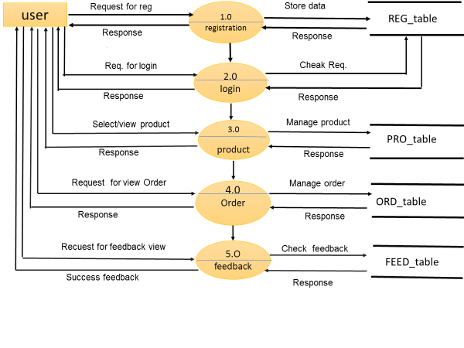

First level of DFD(Admin)

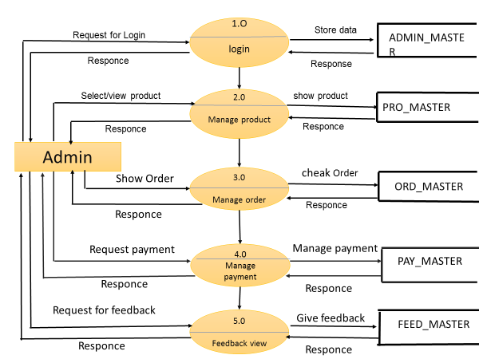

ER-Diagram

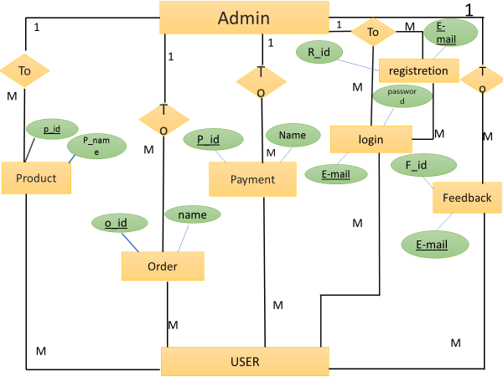

Data Dictionary

M

M

M

M

1

registretion

login

To

M

M

1

M

M

1

M

1

M

1

Product

To

Admin

To

Payment

To

Feedback

To

Database Name:-Database.mdf

* Table Name:-

|  |  |
| --- | --- |
| **NO** | **Table Name** |
| 1 | REG_table |
| 2 | PRO_table |
| 3 | ORD_table |
| 4 | FEED_table |

REG_MST

|  |  |
| --- | --- |
| **Table Name** | **REG_MST** |
| Primary Key | E-mail id |
| Foreign Key | -------- |

|  |  |  |  |  |
| --- | --- | --- | --- | --- |
| **SR NO.** | **FIELD NAME** | **DATA TYPE** | **CONSTRAINT** | **DESCRIPTION** |
| 1 | R_id | Int | Auto inc. | Registration id |
| 2 | F_Name | Varchar(MAX) | Not Null | User full Name |
| 3 | Adress | Varchar(MAX) | Not Null | User Address |
| 4 | Pin code | nchar(6) | Not Null | User pin code |
| 5 | Mono | nchar(10) | Not Null | User Mobile Number |
| 6 | E-mail | Varchar(MAX) | Pk | user E-mail id |
| 7 | Password | Varchar(MAX) | Not Null | User Password |

PRO_MST

|  |  |
| --- | --- |
| **Table Name** | **PRO_MST** |
| Primary Key | P_id |
| Foreign Key | -------- |

|  |  |  |  |  |
| --- | --- | --- | --- | --- |
| **SR NO** | **FIELD NAME** | **DATA TYPE** | **CONSTRAINT** | **DEESCRIPTION** |
| 1 | P_id | Int | PK | Product id |
| 2 | P_Name | Varchar(MAX) | Not Null | Product Name |
| 3 | Brand | Varchar(MAX) | Not Null | Product Brand Name |
| 4 | Price | Float | Not Null | Product Price |
| 5 | Quantity | Int | Not Null | Product quantity |
| 6 | Image | Image | Not Null | Product image |
| 7 | Product type | Varchar(MAX) | Not Null | Product type |

ORD_MST

|  |  |
| --- | --- |
| **Table Name** | **ORD_MST** |
| Primary Key | O_id |
| Foreign Key | ……….. |

|  |  |  |  |  |
| --- | --- | --- | --- | --- |
| **SR NO** | **FIELD NAME** | **DATA TYPE** | **CONSTRAINT** | **DESCRIPTION** |
| 1 | O_id | Int | Pk | Order id |
| 2 | Name | Varchar(MAX) | Not Null | User Name |
| 3 | Address | Varchar(MAX) | Not Null | User address |
| 4 | Pincode | nchar(6) | Not Null | User pin code |
| 5 | Mono | nchar(10) | Not Null | User Mobile Number |
| 6 | Product name | Varchar(MAX) | Not Null | Select product name |
| 7 | Total item | Varchar(MAX) | Not Null | No of total item |
| 8 | P_id | Int | Fk | Product id |

FEED_MASTER

|  |  |
| --- | --- |
| **Table Name** | **FEED_MST** |
| Primary Key | F_id |
| Foreign Key | E-mail id |

|  |  |  |  |  |
| --- | --- | --- | --- | --- |
| **SR NO** | **FIELD NAME** | **DATA TYPE** | **CONSTRAINT** | **DESCRIPTION** |
| 1 | F_id | Int | Auto inc | Feedback id |
| 2 | Name | Varchar(max) | Not Null | User Name |
| 3 | E-mail | Varchar(max) | Fk | User E-mail id |
| 4 | Mono | nchar(10) | Not Null | User Mobile Number |
| 5 | Message | Varchar(max) | Not Null | Message |

**INPUT DESIGN**

INPUT DESIGN FOR USER SIDE

Home Page

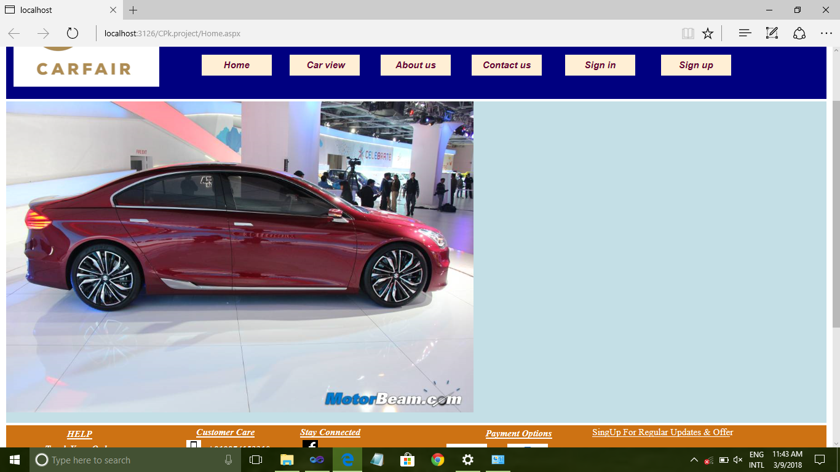

Login page

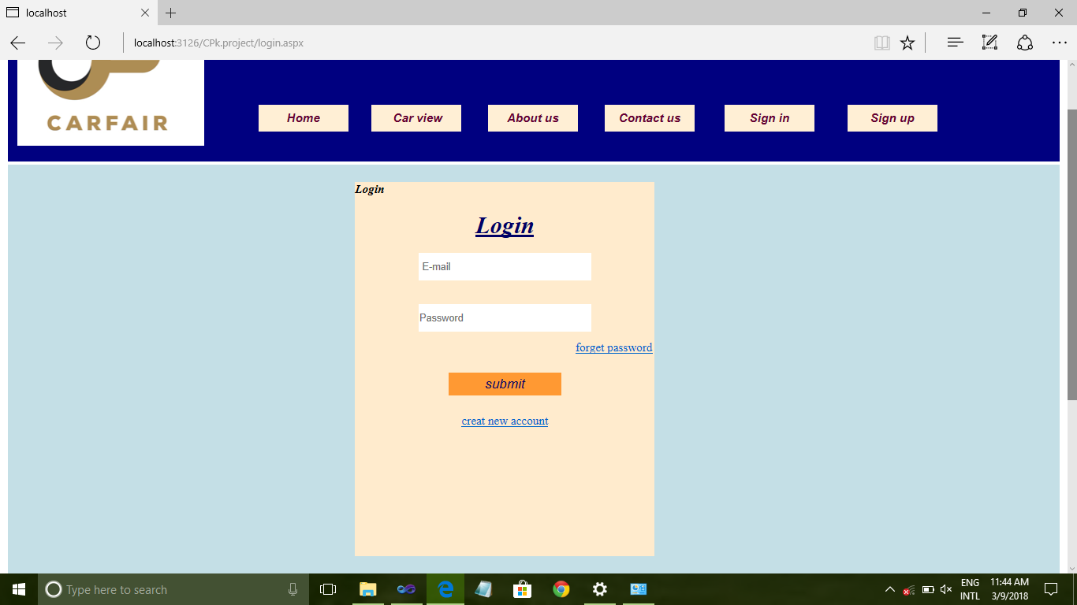

Registration Page

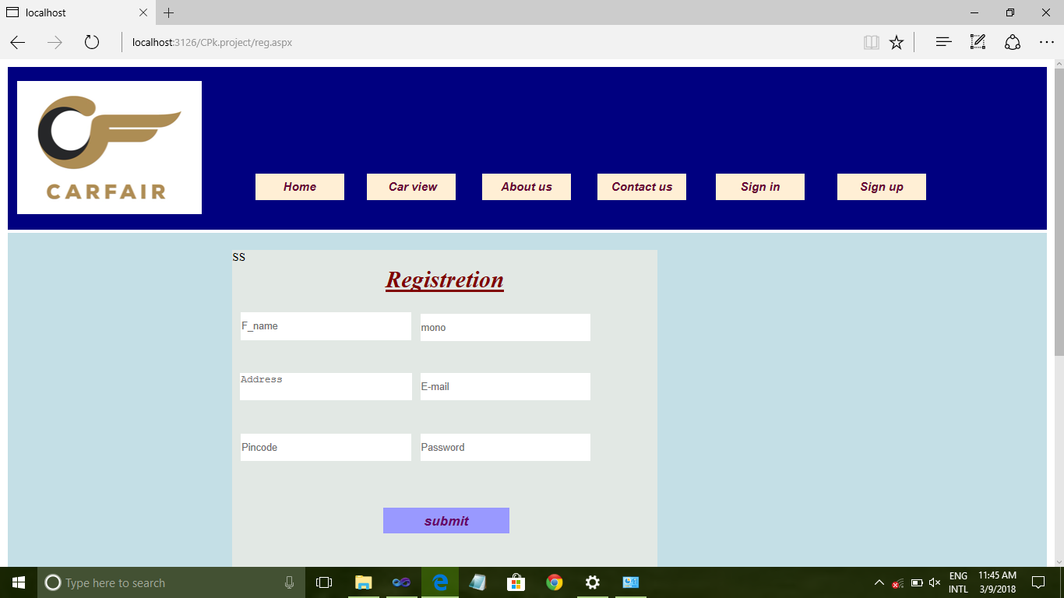

REGISTRATION FROM USING VALIDATION

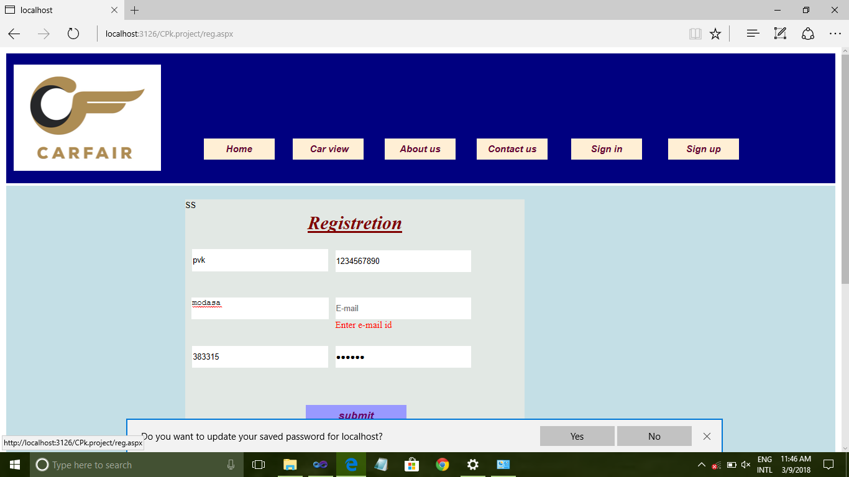

REGISTRATION FROM USING INFORMATION

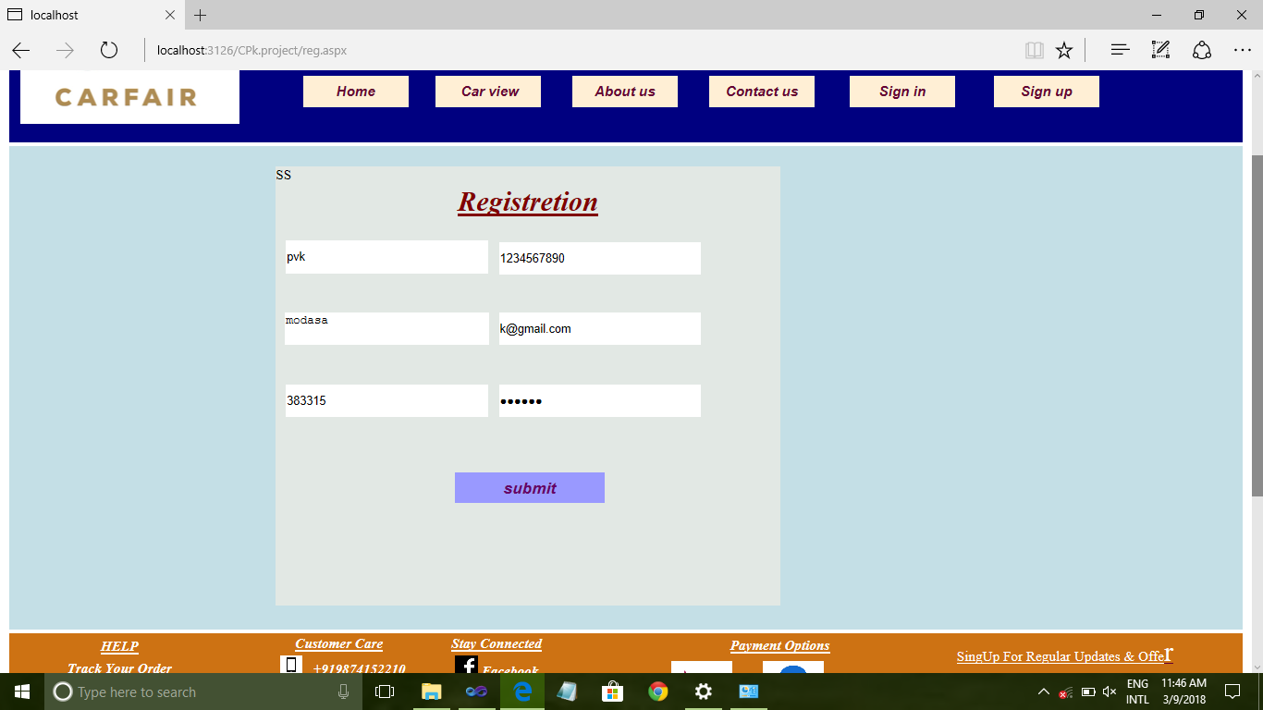

LOGIN FROM USING INFORMATION

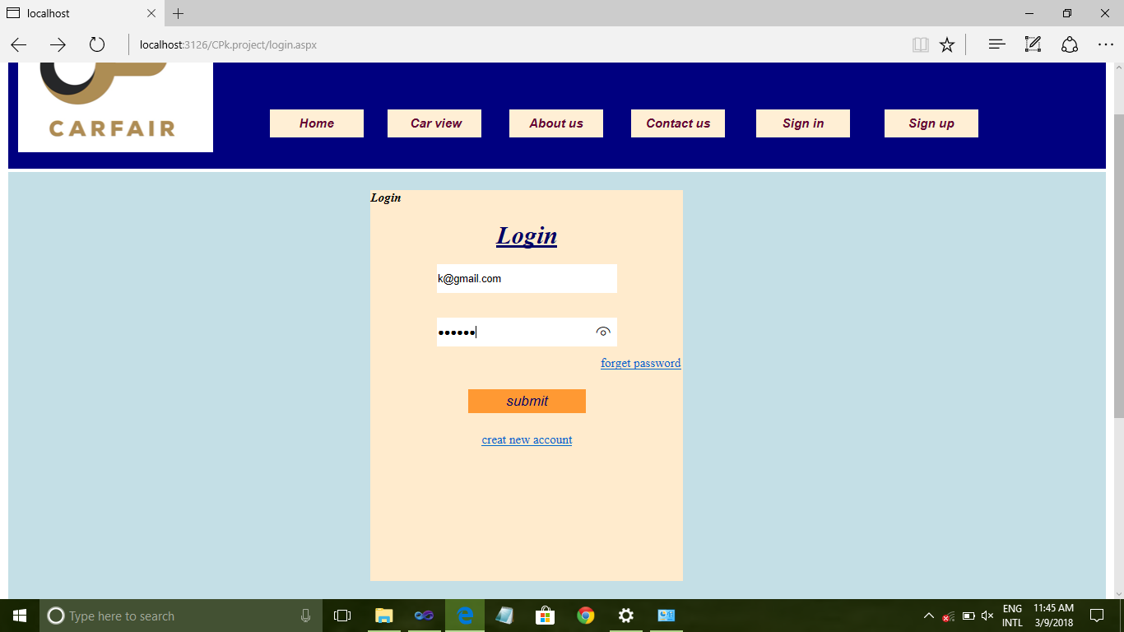

**Car View Page**

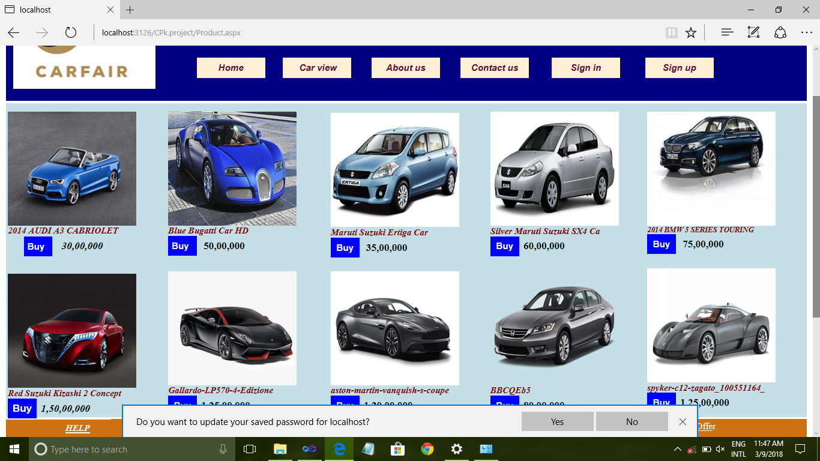

ORDER PAGE

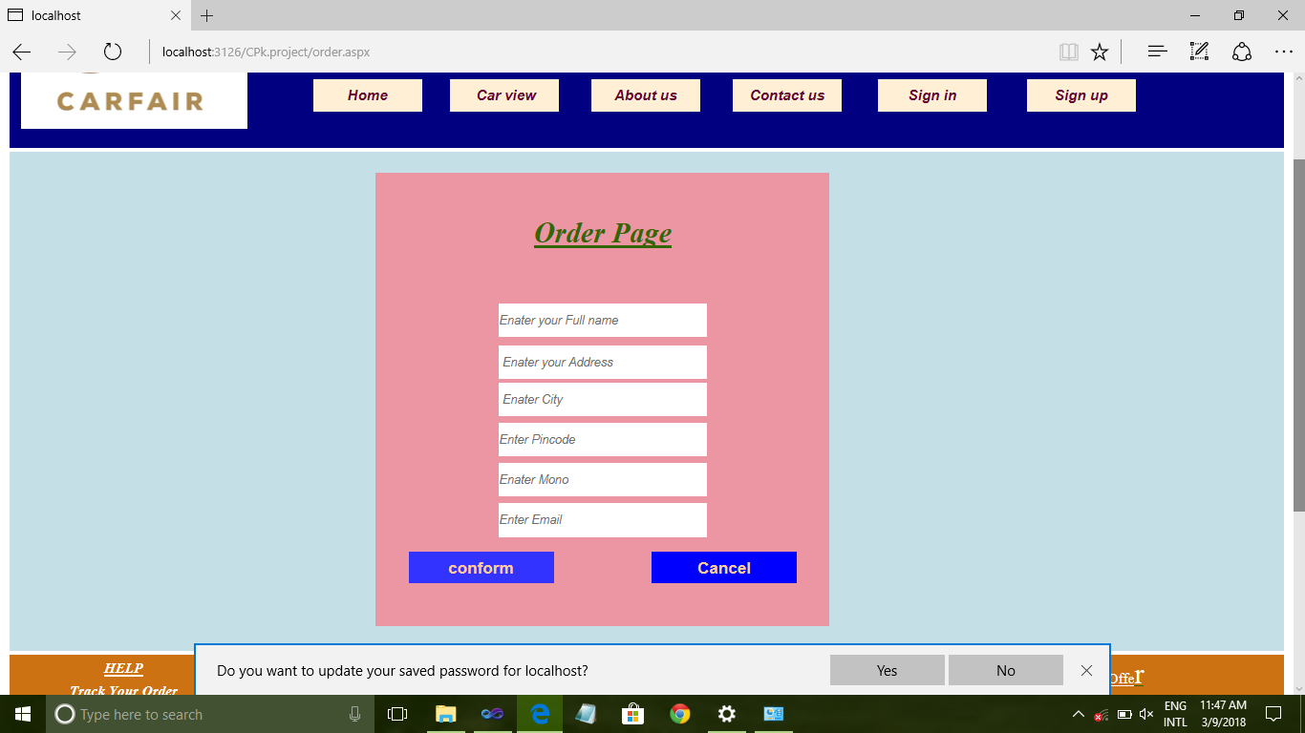

ORDER FROM USING INFORMATION

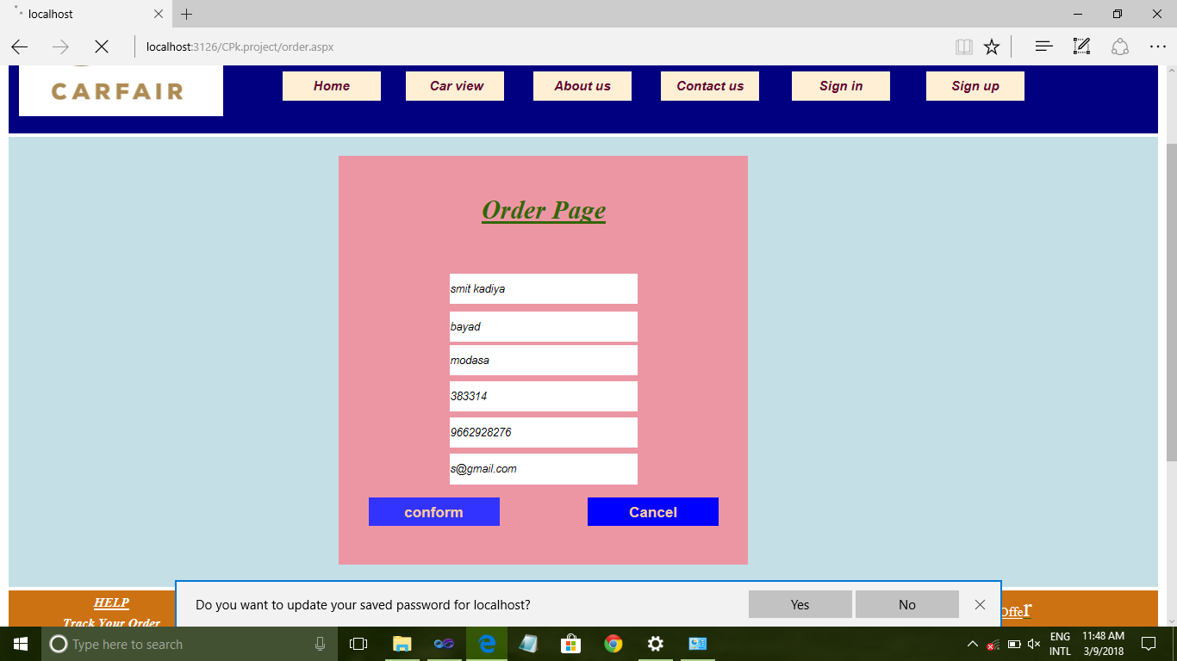

CONFORM PAGE

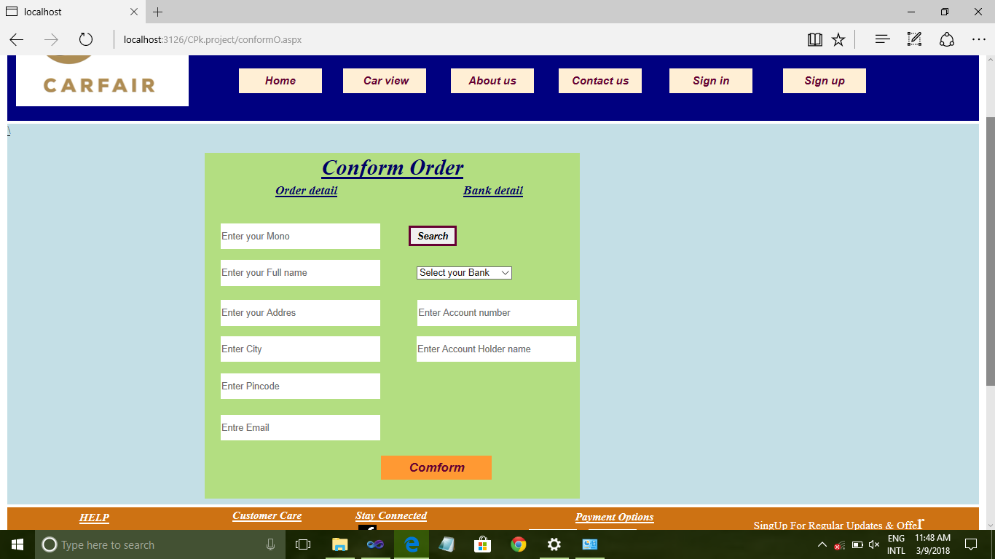

CONFORM FROM USING USER INFORMATION

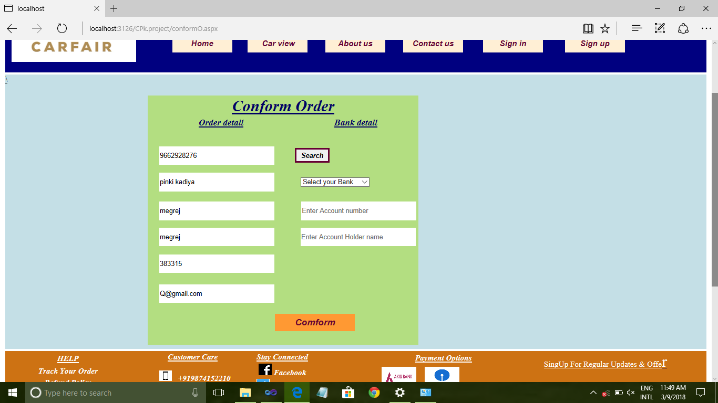

CONFORM FROM USING USER&BANK INFORMATION

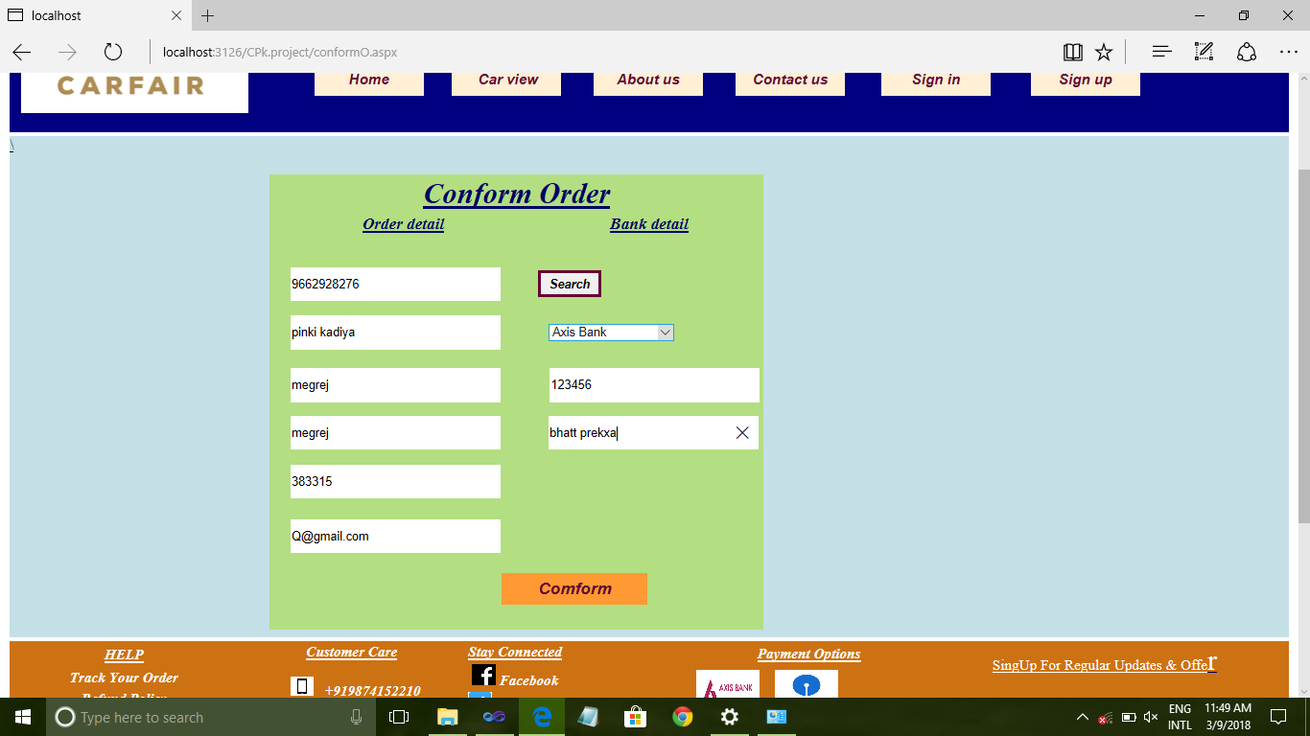

Print Page

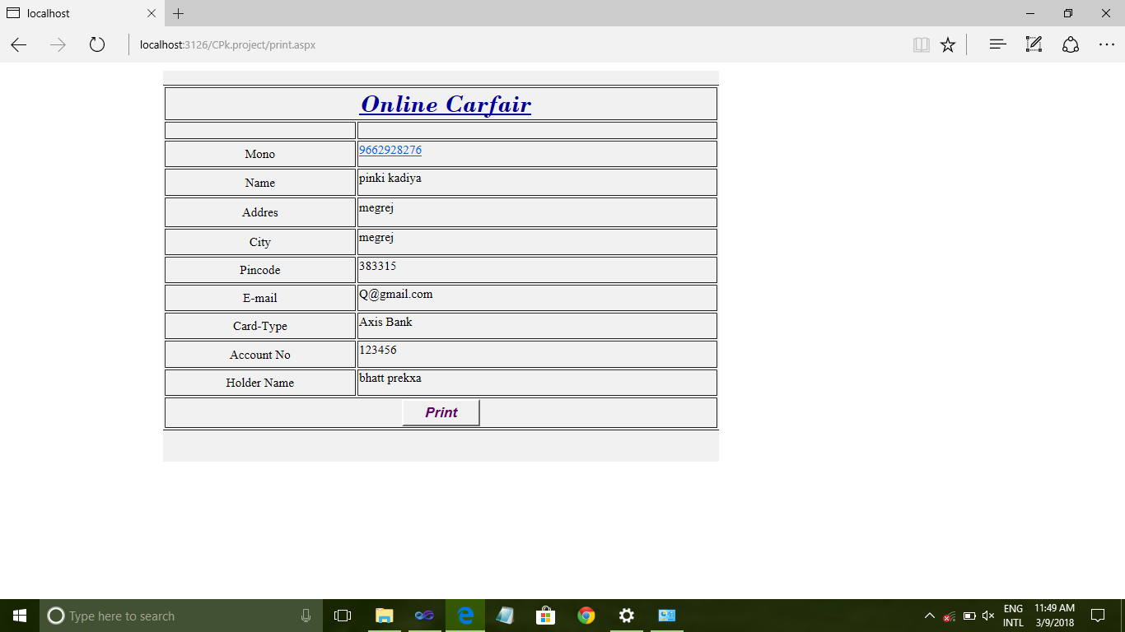

About us Page

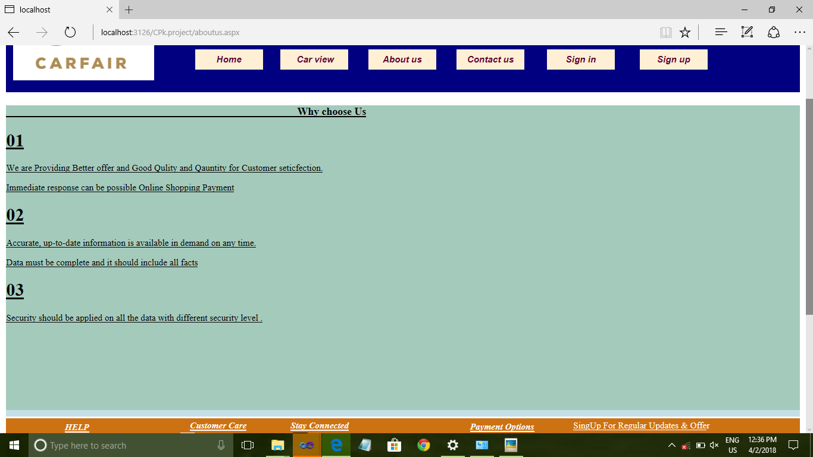

Contact us Page

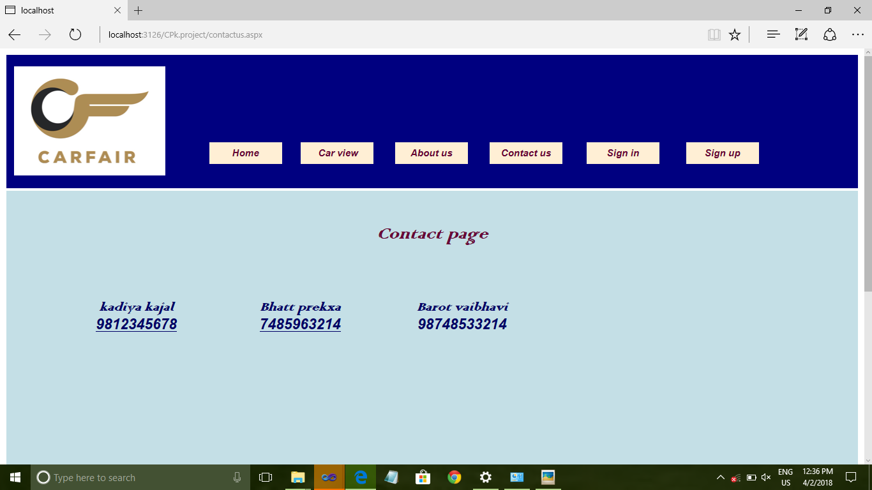

**Admin Side**

Login Page

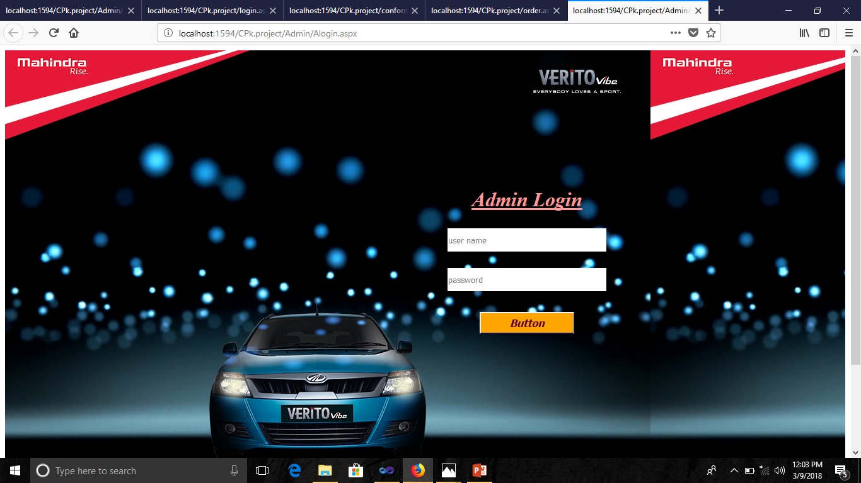

Registration View

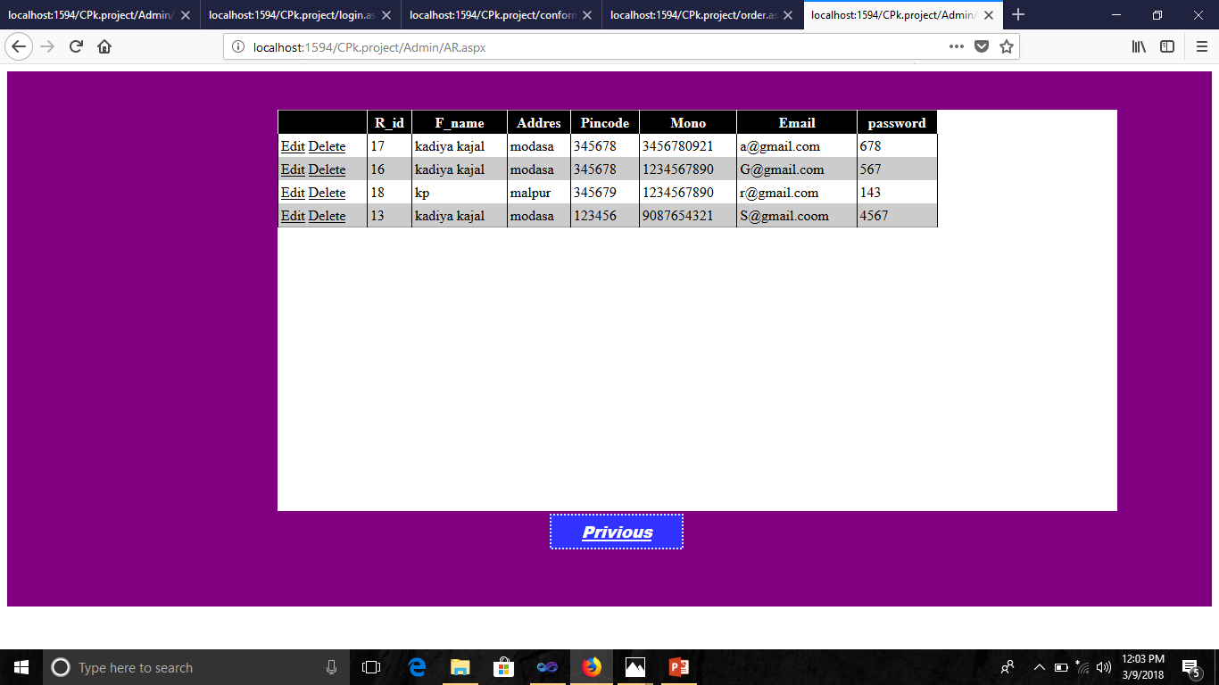

Manage Order

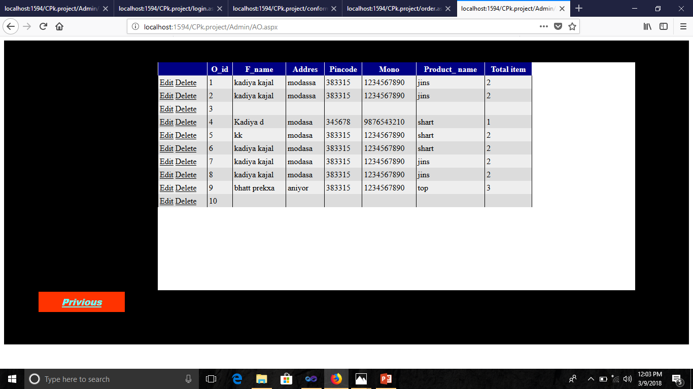

Feedback View

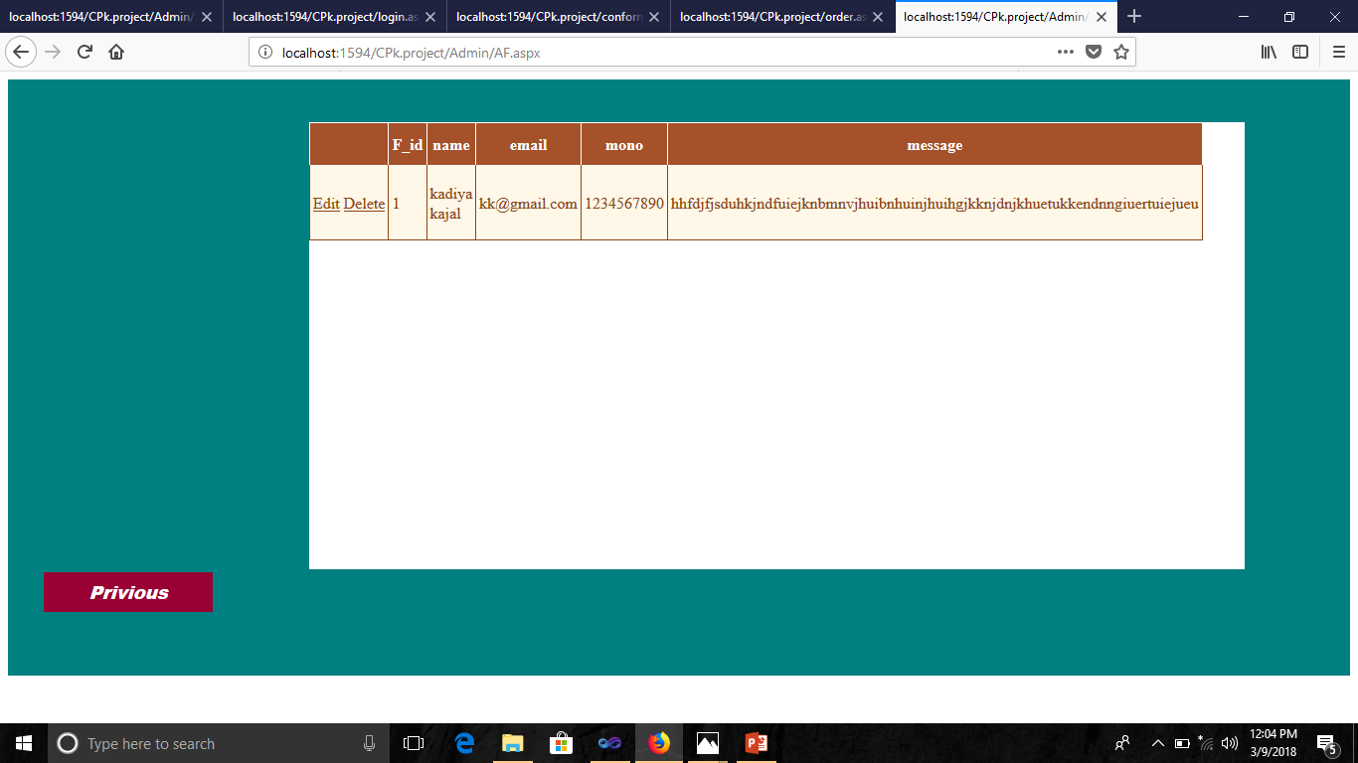

**FUTURE ENHANCEMENT**

There is one segment named lab unit needed computer system to improve work. In this system , we tired to make a simple application for user. We can change our System day by day as per user requirements will be changed. In future , we want to implement below point in our system.

**BIBLOGRAPHY**

|  |  |  |
| --- | --- | --- |
| No | ReferenceBook | Author |
| 1 | Mastering Asp .Net | Wrox Press |
| 2 | Complete Reference Asp .Net | Wrox Press |
| 3 | Database Management System | C.J.Date |
| 4 | System analysis & Design | James A.Sem |

**Website**

[**www.google.com**](http://www.google.com/)

[**www.w3school.com**](http://www.w3school.com/)

[**www.csharp.com**](http://www.csharp.com/)